**DAILY ONLINE ACTIVITIES SUMMARY**

|  |  |  |  |  |  |  |  |
| --- | --- | --- | --- | --- | --- | --- | --- |
| **Date:** | **28/05/2020** | | | | **Name:** | **Amrutha g** | |
| **Sem & Sec** | **4TH&A** | | | | **USN:** | **4AL18CS006** | |
| **Online Test Summary** | | | | | | | |
| **Subject** | | **1.MICRO PROCESSOR AND EMBEDED SYSTEM**  **2.ADALITHA KANNADA** | | | | | |
| **Max. Marks** | | **20**  **50** | | **Score** | | **18**  **19** | |
| **Certification Course Summary** | | | | | | | |
| **Course** | **INTRODUCTION TO DIGITAL MARKETING** | | | | | | |
| **Certificate Provider** | | | **Great learning academy** | **Duration** | | | **2.5 HOURS** |
| **Coding Challenges** | | | | | | | |
| **Problem Statement:1:** C program to find digital root of a number | | | | | | | |
| **Status: executed** | | | | | | | |
| **Uploaded the report in Github** | | | | **YES** | | | |
| **If yes Repository name** | | | | **https://github.com/AMRUTHAGANESH/lockdown-codings** | | | |
| **Uploaded the report in slack** | | | | **YES** | | | |

Online Test Summary 1: 18CS45 online test was scheduled from 12:00 pm to 12:40 pm. The portion for the IA was 2nd module. The question were MCQ type There were 20 question 1 mark respectively duration is 40 minutes .The score I received was 18/20.

Online Test Summary 2: 18KAK49 online test was scheduled from 2:00am to 2:50 am. The portion for the IA was all 10 chapters. The question were MCQ type There were 50 question 1 mark respectively duration is 50 minutes .The score I received was 19/50.

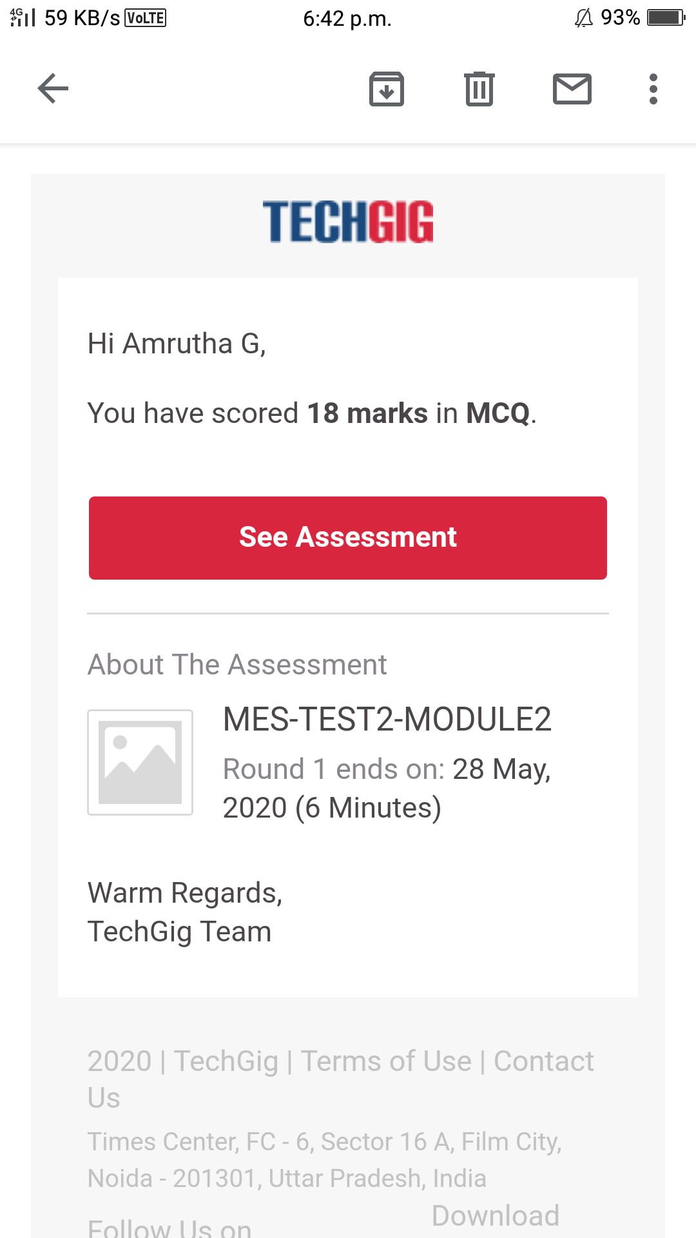

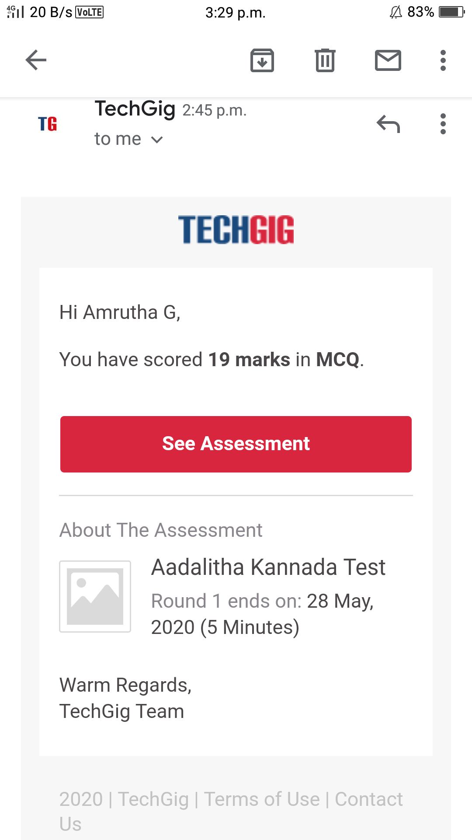

**Online Certification course:**

Name of the course : Introduction To digital marketing

Duration:4.5 hours

Certificate provider: great learning academy

Today I learnt types of ads



This the snapshot of the new course.

Online Coding summary:

1. C program to find digital root of a number

